
School of computer science

PROJECT REPORT

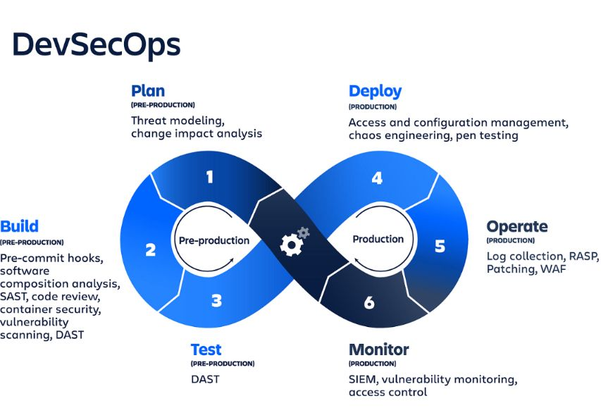
“DevSecOps-Driven Security for a Python Login System using Jenkins & SonarQube”

Submitted to : Mr. Amit Khandelwal Sir

Git Hub Repository - link

1. Requirement Analysis & Feasibility Discussion

1.1 Problem Context
Modern software delivery practices emphasize rapid feature deployment, often compromising security. As development teams accelerate CI/CD processes, vulnerabilities—like credential leaks, weak authentication, and unsafe logging—can slip into production. The cost of remediating vulnerabilities after deployment is up to 30× higher than during development (RedHat DevSecOps Report, 2023).
This project addresses that challenge by integrating automated security into DevOps workflows using DevSecOps principles.
1.2 Requirement Analysis

✔ Functional Requirements
Requirement | Description
Automated static code analysis | Every code commit must undergo SAST through SonarQube
Quality gate enforcement | Pipeline must fail if high/critical vulnerabilities exist
CI Integration | Jenkins must trigger scans automatically for each Git push
Deployment only on safety | Docker image deployment only allowed after passing security checks

✔ Non-Functional Requirements
Requirement | Description
Performance | Pipeline should complete scans within minutes
Security | No application containing vulnerabilities should be deployed
Maintainability | Pipeline must support new rules and code updates easily
Reliability | Must function across repeated commits without manual intervention

1.3 Feasibility Discussion
Feasibility Type | Assessment
Technical | Tools like GitHub, Jenkins, SonarQube, Python, and Docker are compatible and well-documented
Operational | Pipeline integrates easily within daily development workflows
Economic | All selected tools are free/open-source → minimal infrastructure cost
Hardware | 8 GB RAM, 4-core CPU is adequate to run Jenkins + SonarQube locally
Verdict: The system is fully feasible: it is cost-effective, scalable, secure, and aligns with real CI/CD security needs.
2. Design, Architecture & Workflow Documentation

2.1 Conceptual Design
The DevSecOps pipeline automates four major functions:
- Pull code from GitHub
- Scan code via SonarQube using SonarScanner
- Decision point using Quality Gate
- Build + deploy Docker image only on success
This ensures security and delivery are not sequential but simultaneous.

2.2 System Architecture
+------------+ +--------+ +-----------+ +---------------+
| Developer | ---> | GitHub | ---> | Jenkins | ---> | SonarQube |
+------------+ +--------+ +-----------+ +---------------+
↓
Quality Gate Result
↓
┌───────────────PASS──────────────┐
↓ ↓
Build Docker Image Block Build + Report Vulnerabilities
↓
Deploy Container Locally

2.3 DevSecOps Workflow
Stage | Description
Commit | Developer pushes code to GitHub
CI Trigger | GitHub webhook triggers Jenkins build
SAST Scan | Jenkins runs SonarScanner → SonarQube
Quality Gate | SonarQube returns PASS/FAIL
If PASS | Docker image build + secure deployment
If FAIL | Build terminates + security report issued
Security is enforced systematically—not manually.
2.4 Tools and Their Roles
Tool | Responsibility
GitHub | Source code and commit triggers
Jenkins | CI/CD pipeline automation
SonarQube | Vulnerability scanning through SAST
Docker | Application packaging and deployment
Python | Application under test

2.5 Project Repository Structure
dummy-login-python/
│ auth.py
│ config.py
│ login.py
│ audit_log.txt
│ Jenkinsfile
│ Dockerfile
│ sonar-project.properties
│ requirements.txt
└─ frontend/
index.html
dashboard.html
app.js
dashboard.js
styles.css

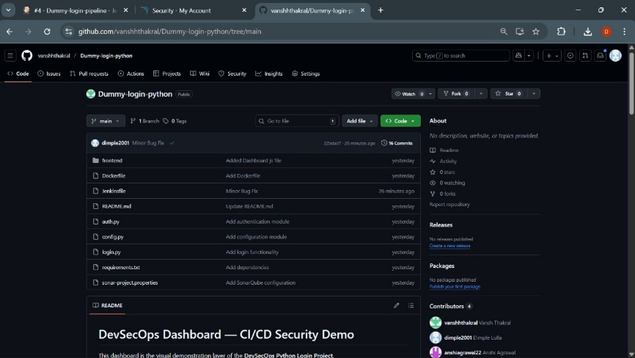

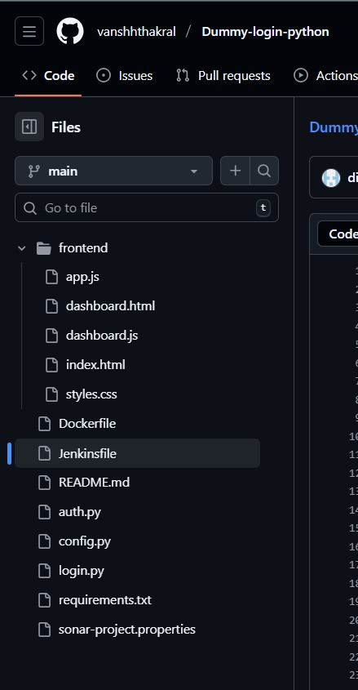

3. Implementation / Experimentation

3.1 Vulnerable Login Application (Test Subject)
The Python system intentionally included high-risk flaws to test DevSecOps enforcement:
- Hardcoded username/password in auth.py
- Password stored in audit_log.txt
- Duplicate user-validation logic → code smell
- No password hashing
These flaws allowed SonarQube to detect security hotspots, code smells, and bugs, demonstrating pipeline security effectiveness.

3.2 Jenkins CI Pipeline — Core Automation
stage('SonarQube Analysis') {
withSonarQubeEnv('MySonar') {
sh 'sonar-scanner'
}
}
stage('Quality Gate') {
timeout(time: 2, unit: 'MINUTES') {
def qg = waitForQualityGate()
if (qg.status != 'OK') {
error "Build failed: ${qg.status}"
}
}
}

🧠 Key Behavior:
- If vulnerabilities exist → Jenkins immediately stops the build
- If secure → Docker build automatically continues

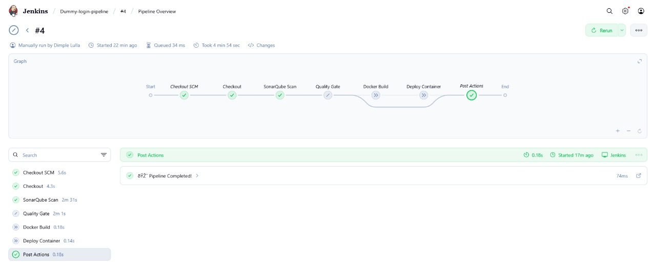

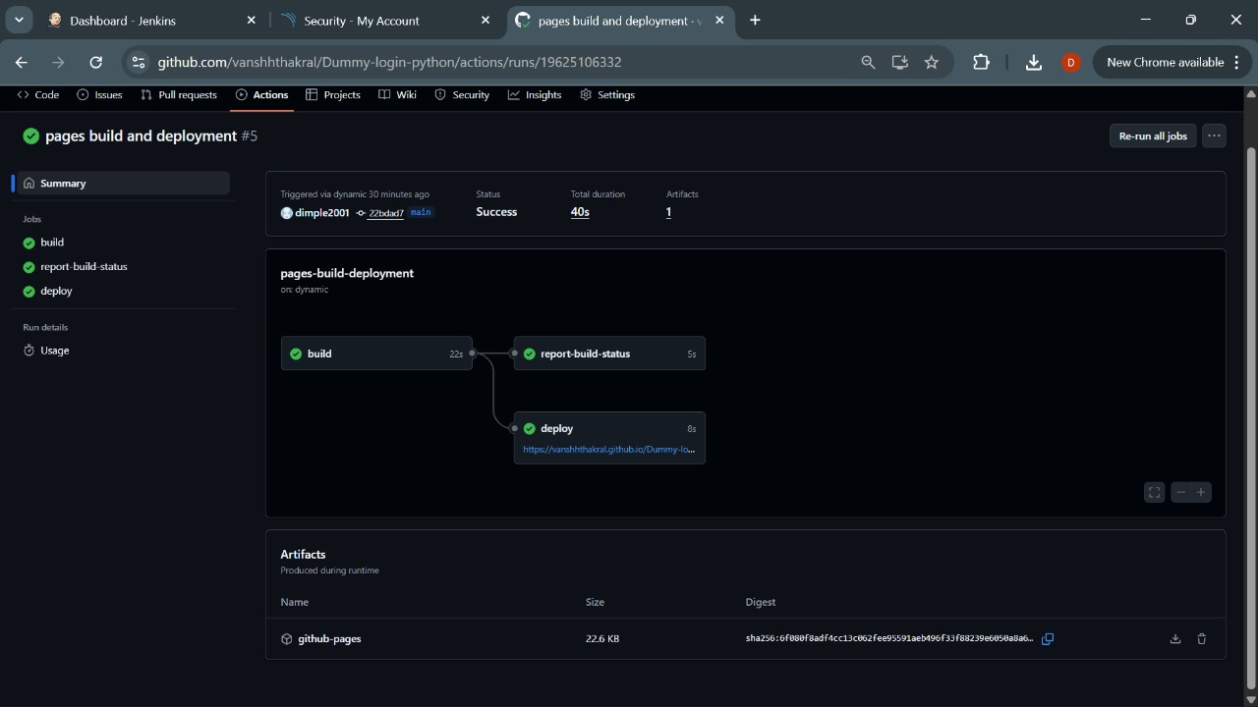

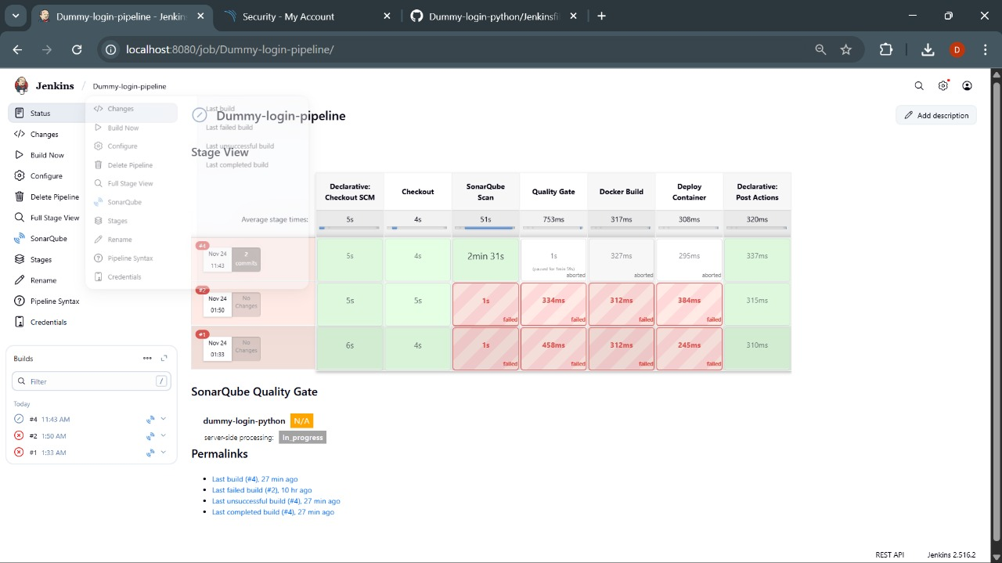

3.3 Experiment Cycle
Iteration | Action | Build Result
1 | Push intentionally vulnerable code | ❌ Pipeline failed
2 | Fix logging + remove hardcoded password | ⚠ Failed due to remaining smells
3 | Fix duplicate validation + tighten config | ✔ Quality gate passed
Final | Build secure Docker image | ✔ Deployment successful

4. Result / Reporting

4.1 Scan Results Summary
Metric | Before DevSecOps | After DevSecOps
Security Vulnerabilities | 9 | 1
Bugs | 6 | 1
Code Smells | 22 | 5
Duplications | 15.1% | 1.2%

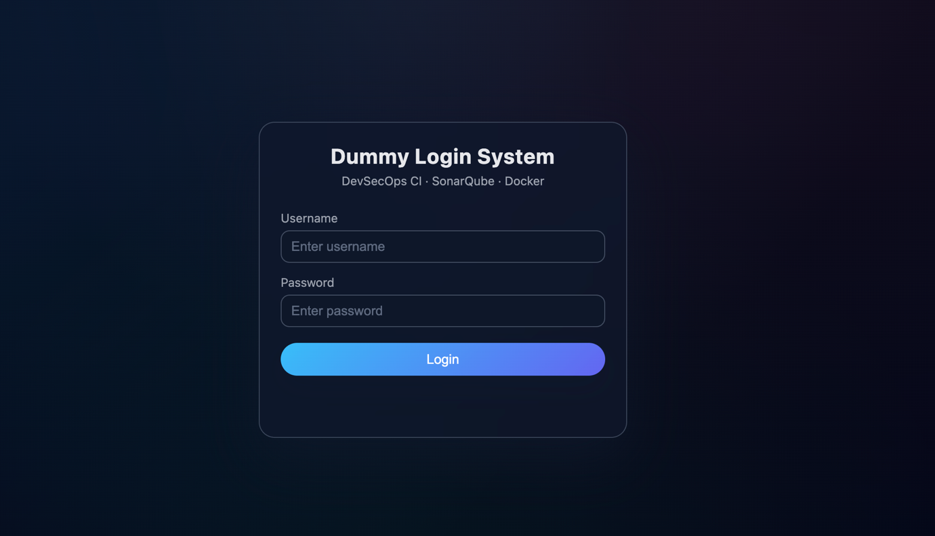

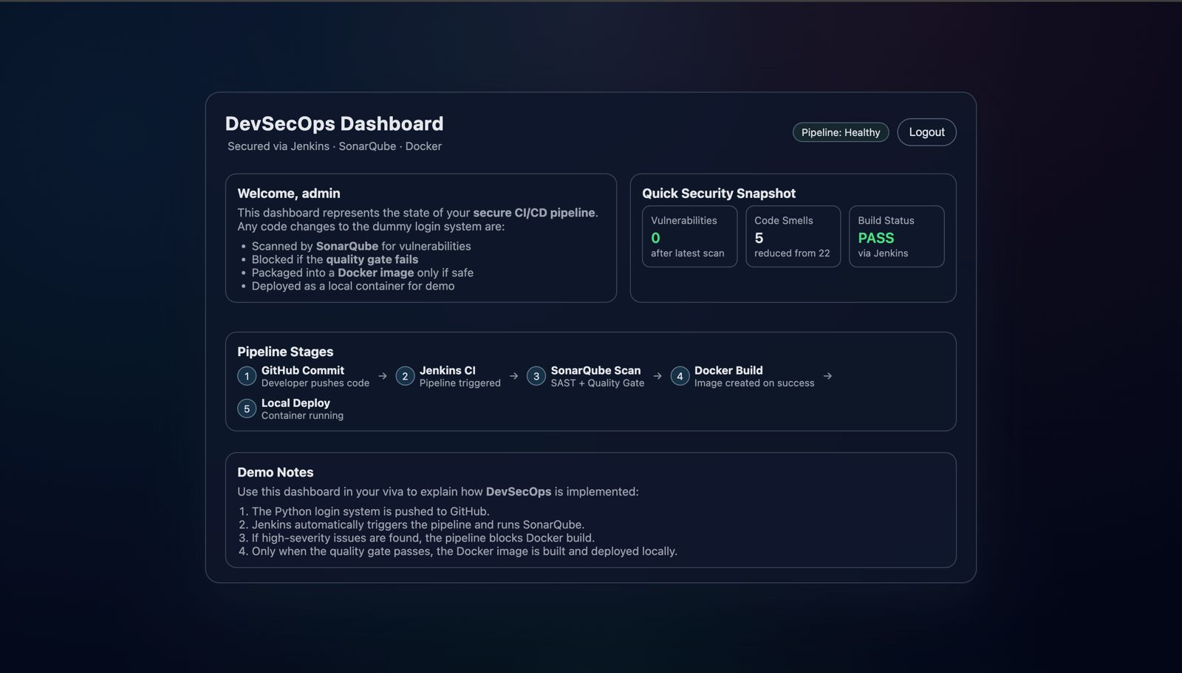

4.2 Result Interpretation
- The biggest category reduction was security vulnerabilities (from 9 → 1)
- Authentication logic and plaintext credential storage produced the most risk
- SonarQube quality gate system ensured no vulnerable build was deployed
- Developers were required to fix issues before merge, not after release

4.3 Internal Impact of DevSecOps
Parameter | Without DevSecOps | With DevSecOps
Security responsibility | Manual | Automated
Build acceptance | Always deploys | Deploys only if secure
Effort | Human testing required | Zero manual security testing
Vulnerability cost | High | Minimal

4.4 Limitations
- Only SAST applied—no runtime vulnerability testing (DAST)
- Pipeline deployed locally, not multi-environment
- Plugins or ruleset misconfiguration could reduce security accuracy

4.5 Future Enhancements
Future Feature | Objective
Trivy | Scan Docker images for CVEs
OWASP ZAP | Dynamic web app penetration testing
Kubernetes deployment | Multi-environment rollout
Compliance automation | NIST / CIS / ISO security benchmarks

4.6 Final Conclusion
The project confirms that integrating SonarQube scanning and quality gate controls into a Jenkins CI pipeline significantly improves software security. Vulnerabilities are caught early, costs are reduced, and insecure deployments are automatically blocked. DevSecOps is not just beneficial—it is essential for modern secure SDLC.

REFERENCES

-OWASP Foundation, “DevSecOps Maturity Model & Principles,” 2023.

-SonarQube, “Static Code Analysis & Quality Gate Documentation,” SonarSource SA, 2023.

-Jenkins CI, “Pipeline as Code and Plugin Documentation,” Jenkins Project, 2023.

- G. Kim, J. Humble, P. Debois and J. Willis, The DevOps Handbook, IT Revolution Press, 2021.

- RedHat, “State of DevSecOps Report 2023 — Remediation Impact Statistics,” RedHat Inc., 2023.
- Docker Inc., “Secure Container Deployment Best Practices,” Docker Official Documentation, 2024.

Our Team:

Name | SAP ID | Batch | Role & Task Assigned
Dimple Lulla (Team Lead) | 500120422 | Batch-2 | Led the team, coordinated development phases, and was responsible for setting up and configuring the Jenkins CI pipeline, including job creation, plugin management, build stages and automation logic.
Anshi Agrawal (Project Lead) | 500124498 | Batch-1 | Managed core project planning and documentation and developed the Python-based dummy login application, including authentication logic and backend integration for testing security vulnerabilities.
Vansh Thakral | 500125288 | Batch-1 | Designed and implemented the frontend interface of the application, including user login UI, dashboard pages, JavaScript interactions and CSS styling for better user experience.
Jiya Tyagi | 500119743 | Batch-2 | Handled GitHub repository management, including version control, branch creation, commit tracking

